**PROJECT REPORT**

**ON**

**BAKERY PRODUCT**

**MANAGEMENT**

**SYSTEM**

**SUBMITED BY**

**MISS. MANUJA RANGARAI EKAL**

**AND**

**MISS. SANIKA YASHAVAT REDEKAR**

**(B.SC |||)**

**TO**

**SHIVAJI UNIVERSITY, KOLHAPUR**

**FOR THE AWARD OF**

**Under the Guidance of**

**MR V.S.MANE SIR**

# SADASHIVRAO MANDLIK MAHAVIDYALAYA, MURGUD

**2024-2025**

**A PROJECT REPORT ON**

**BAKARY PRODUCT MANAGEMENT**

**SYSTEM**

* **Submited By:**

1. **MISS. MANUJA RANGARAI EKAL**

2. **SANIKA YASHAVAT REDEKAR**

* **Guided By**:

**Mr. V.S.MANE Sir**

**Assistant Professor**

SADASHIVRAO MANDLIK MAHAVIDYALAYA, MURGUD

CERTIFICATE

This to certify that **Miss.** . **MISS. MANUJA RANGARAI EKAL** and **Miss. Sanika YASHAVAT REDEKAR** has successfully completed the project on the topic **“BAKARY PRODUCT MANAGEMENT SYSTEM”** under my supervision and guidance, in a satisfactory manner for partial fulfillment of B.SC ||| degree for the academic year 2024-2025.

Date:

Place: MURGUD

**Guide**  **Examiner**  **H.O.D**

**Mr. V.S.MANE Mr. V.S.MANE Sir**

Assistant Professor Assistant Professor

Department of Department of

Computer Science Computer Science

# SADASHIVRAO MANDLIK MAHAVIDYALAYA, MURGUD

To,

The Register,

Shivaji University,

Kolhapur.

**Subject:** Recommendation for B.Sc. ||| project

Respected sir,

I shri. S. D. Patil the principal of SADASHIVRAO MANDLIK MAHAVIDYALAYA, MURGUD recommend that the following student

. **MISS. MANUJA RANGARAI EKAL**

And

. **SANIKA YASHAVAT REDEKAR**

Have completed the project report entitled, **“BAKERY PRODUCT MANAGEMENT SYSTEM”** as per partial fulfillment according to the syllabus of the Shivaji University, Kolhapur under the guidance of V.S.MANE

**Date:**

The Principal

**Place:** MURGUD

# SADASHIVRAO MANDLIK MAHAVIDYALAYA, MURGUD

**Tal- Kagal**

**Dist- Kolhapur**

**GUIDENCE**

This is to certify that the project entitled “Bakery Product Management System” conducted for SADASHIVRAO MANDLIK MAHAVIDYALAYA, MURGUD by Miss. . **MISS. MANUJA RANGARAI EKAL** And **SANIKA YASHAVAT REDEKAR** in partical fulfillment of this work for award of Bachelor of Science (Computer Science) submitted to Shivaji University, Kolhapur has been completed under my supervision and guidance.

To the best of my knowledge and brief the master presented by him is original in nature and has not been copied from any source. Also, this report has not been submitted earlier for any degree or diploma of Shivaji University or any other University.

**Date:** Mr V.S.MANE

**Assistant professor**

**Place:** MURGUD

**Declaration**

We Undersigned hereby declare that this report entitled **“Bakery Product Management System”** is original work prepared by us under guidance of Mr. Amit Patil. The empirical findings in this report are based on data collected by us. The matter presented in this report is not copied from any source. We undersigned that any such copy is liable for punishment in any way the University Authorities deem to fit. This work has not been submitted to the award of degree to Shivaji University, Kolhapur or any other University.

This work is humbly submitted to Shivaji University for the award of the degree of Bachelor of Science (Computer Science)

**Date:**

**Place: MURGUD**.

. **MISS. MANUJA RANGARAI EKAL**

And

**SANIKA YASHAVAT REDEKAR**

.

**ACKNOWLEDGEMENT**

It gives us great pleasure to remain deeply indebted to our guide Mr. Amit Patil sir. Under whom we had the privilege to work. The faith and confidence shown by him in us boosted our moral and motivated to perform our better in preferring this project.

We express our sincere thanks to **Mr. Mayur Patil**

Who had given an opportunity for collecting the information at SADASHIVRAO MANDLIK MAHAVIDYALAYA, MURGUD

We also take this opportunity to express our gratitude to the Head of Dept. Mr. MANE V.S. . for providing us with the required facilities for the academic achievement.

We wish to record our sense of obligation to our parents for encouraging us to take up this course and also proceeding continuous financial assistance to us for enabling us to undergo this course and completion of the project.

Finally we are thankful for all of them who have contributed either directly or indirectly to this project.

Thanking You,

**INDEX**

# 

1. **ORGANISATION PROFILE**

**2. ABOUT PROJECT**

* 1. Existing Manual System……………………....
  2. Limitations Of Manual System…………………
  3. Proposed System……………………………………

**3.SYSTEM ANALYSIS**

* 1. Methodology……………………………………………
  2. Classic Life Cycle……………………………………
  3. Data Flow Diagram (DFD)………………………
  4. Entity Relationship Diagram……………………

**4.TOOLS USED**

* 1. Stamp and Software Requirements…
  2. Front End (C#.NET) ………………………………
  3. Controls of C#.NET…………………………………
  4. Back End (SQL server 2014) ………………………….
  5. Crystal Report……………………………………….

**5.DATABASE STRUCTURE**……………………………………………..

**6. INPUTS (FORM LAYOUT)** …………………………………..

**7. OBJECTIVES, SCOPE AND CONCLUSION**…………

**8. TESTING**………………………………………………………………

**9. LIMITATIONS OF PROPOSED SYSTEM**……………

**10. BIBLIOGRAPHY**…………………………………………………

Chapter 1

**ORGANIZATION**

**PROFILE**

**1.ORGANIZATION PROFILE**

In order to provide better communication facility, Mr. Mayur Patil gives us a good

information about “**Bakery Product Management System**”. It is a well-known

Bakery in MURGUD.

It has made a better position in  **MURGUD Village,** due to its

better ability of Providing Healthy and Testy Bakery Product.

Chapter 2

ABOUT PROJECT

**2.1 EXISTING MANUAL SYSTEM**

**2.2 LIMITATIONS OF MANUAL SYSTEM**

**2.3 PROPOSED SYSTEM**

**2.1 EXISTING MANUAL SYSTEM**

* The Bakery Management System is working manually. The current system is very time consuming and costly because it involve lot of paper work. To manually handle such a system existing system is very difficult task but now a days because of compurterization of these job is becoming easier following are the reason why the current system should be computerized.
* To increase efficiency with reduced cost.
* To reduce the burden of paper work.
* To save the time of recording details of every work undertaken by Bakery.
* To check that the request for particular product is available. To generate report easily.

**2.2 LIMITATIONS OF MANUAL SYSTEM**

* The existing system is much time consuming.
* Much inefficient as the change of mistake are increased in manual work.
* It is difficult to manage numerous register.
* It is unsafe as anyone can have access to it.

**2.3 PROPOSED SYSTEM**

1. Bakery Management System is totally computer based software application to maintain day to day transaction in a bakery. This software helps to store all bakery items with category and sub-category. It also maintains record of purchase and sales. It maintain details of Supplier.
   1. **Goals Of Computerization-**

Planned approach towards working:

We cannot achieve success in any work without planning. Hence with the help of computerization we can give planned approach towards working.

Large data storage:

We can store large amount of data. Each and every detail of Student information, records or fee detail can be stored. Once the data is stored, we can retrieve the data any number of times.

Easy Search:

Searching any specific record becomes easier. Just enter the unique id and you will get the corresponding information very faster. Hence no need to check the registers even for verifying the student’s details, fee details etc.

Accuracy Process:

Computer are very accurate than man. Computers calculate anything without any mistake. Hence, we can reduce the mistakes that may be caused during manual works.

Reliability:

The reliability of the proposed system will be high due to the above stated reasons. The reason for the increased reliability of the system is that now there would be proper storage of information.

No Redundancy:

In the proposed system utmost care would be that no information is repeated anywhere, in storage or otherwise. This would assure economic use of storage space and consistency n the data stored.

Easy and Fast Process:

One of the important features of the computer is its speed. It works very faster than a man. We can easily update, insert and delete the data as it is faster we can get the particular information within no time. It reduces the checking of registers for getting information manually.

Reports:

Due to computerization getting reports is very easy and printouts of the reports can be easily taken.

Cost Factor:

Due to computerization extra manpower for keeping records is not needed.

Chapter 3

**SYSTEM ANALYSIS**

**3.1 Methodology…………………………....**

**3.2 Classic Life Cycle………………….….**

**3.3 Data Flow Diagram…………………...**

**3.4 Entity Relationship Diagram….…….**

3.1 METHODOLOGY

To design a computerized system, we have followed the software engineering approach. We have chosen classic life cycle approach for software development. This phenomenon includes System Design, System analysis, & Testing, which is followed by again first phase i.e. repeating the cycle.

System design means understanding the old system completely and planning a new system or to replace or complement the existing system. System analysis means identification, understanding and critically examine the system and its parts (sub system) for the purpose of achieving the goals set of the system as a whole, through modifications, changed interrelationships of component, deleting, merging or separating the components. The methodology of system analysis involves.

1. Identification of system (setting system boundary)
2. Understanding the role and interrelationship of elements with other elements of the same system.

Outcome of the system analysis job is a set of recommendations towards creating system, which best meets, its objectives giving due regards to cost effectiveness and risks.

**3.2 SYSTEM ANALYSIS**

* **The Process Model used For the System :-**

The process model used for this system “Classic Life Cycle” as this is simple and is best for small scale project.

The “Classic Life Cycle” is also called as system development life cycle (SDLC). It is defined “The growth of an information system is through various identifiable stages. These stages are grouped together and referred as SDLC.” The structure of its stages which we used in our project is as follows:

**System Engg.**

**Analysis**

**Design**

**Code**

**Testing**

**Maintenance**

**ZEROTH LEVEL :** 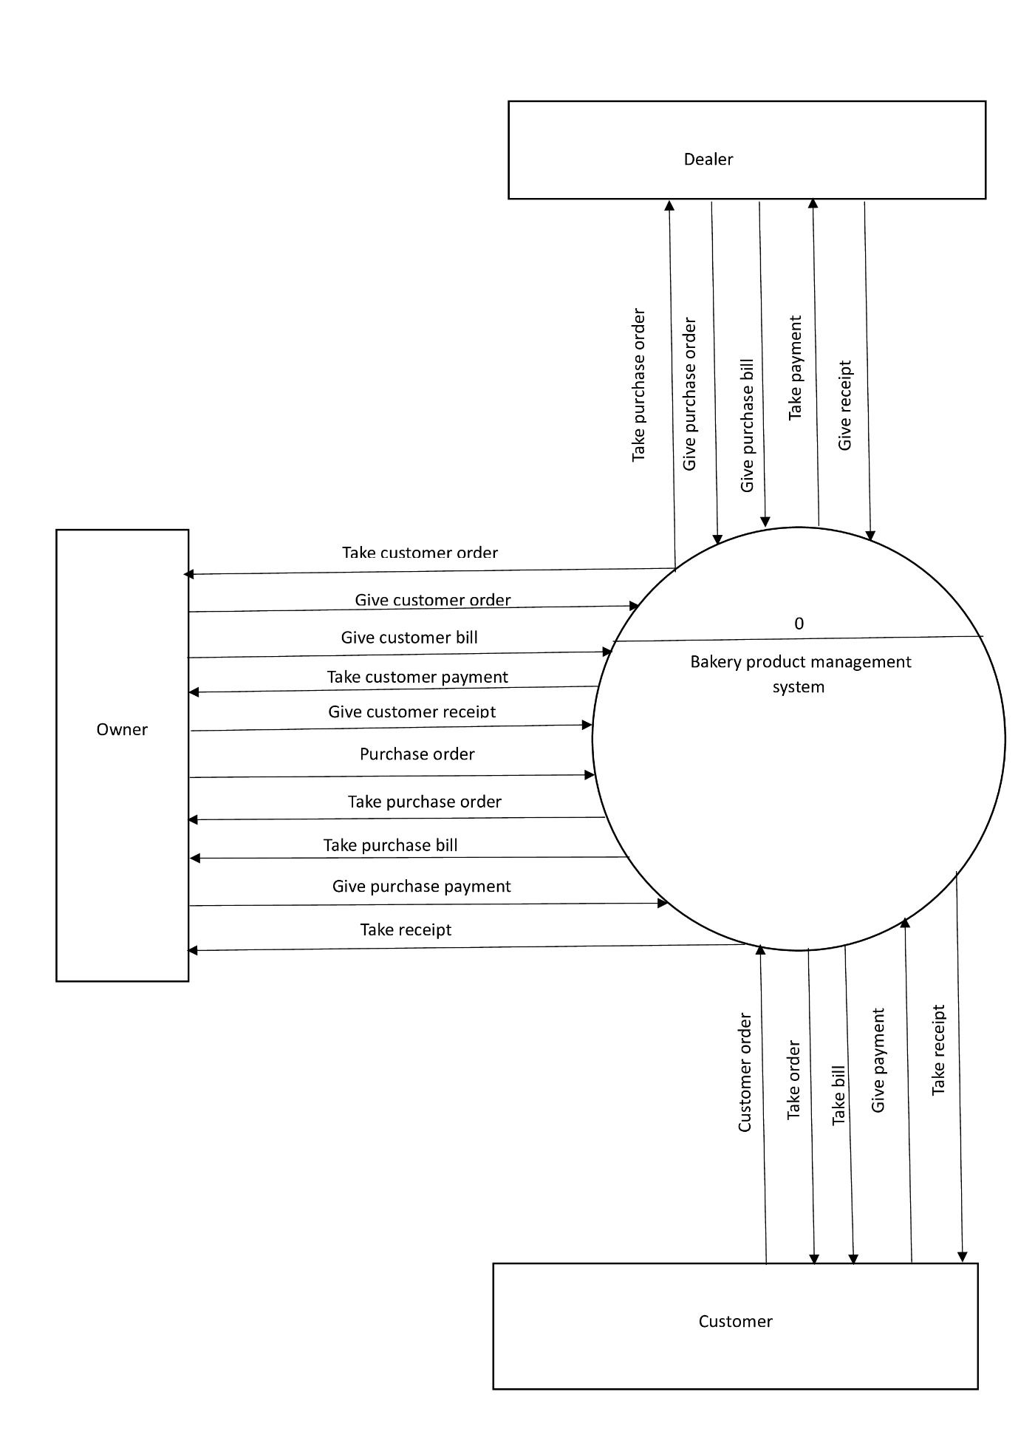

**FIRST LEVEL :**

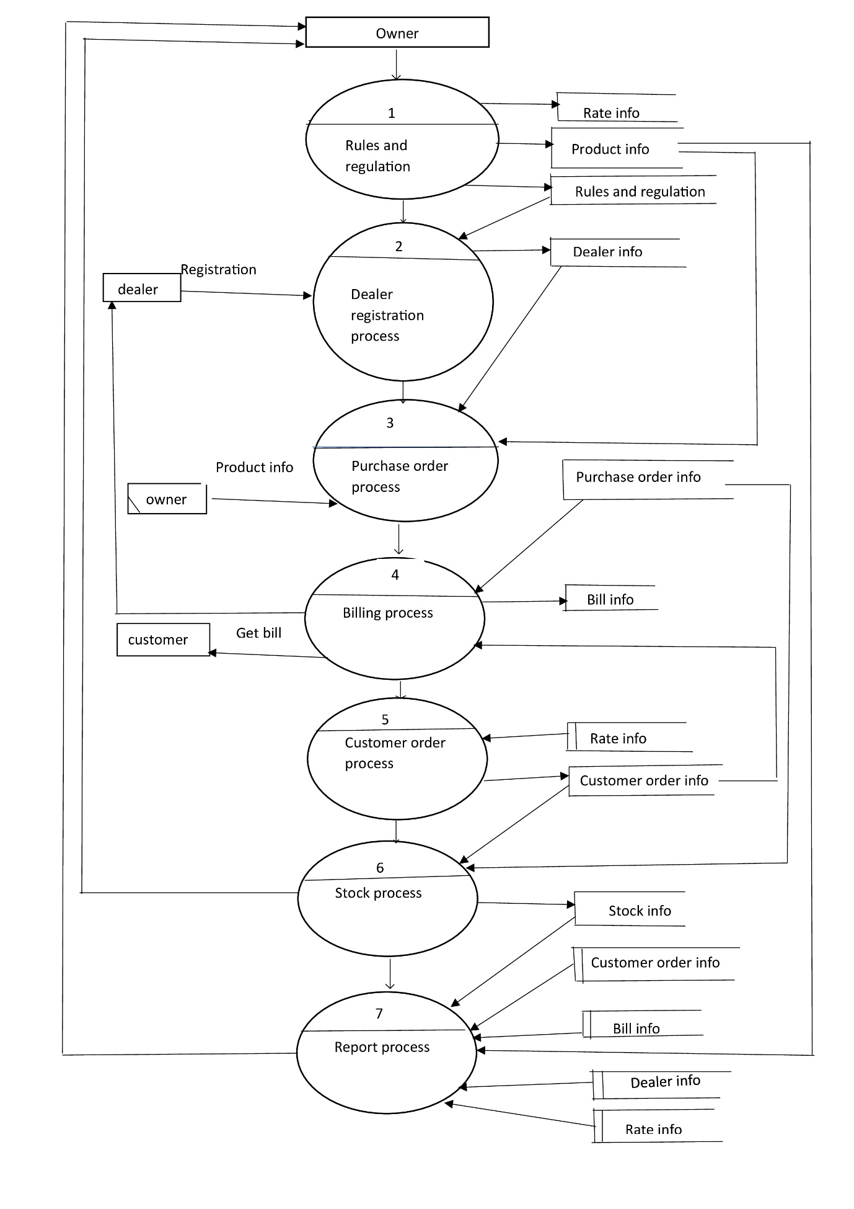

**SECOND LEVEL :**

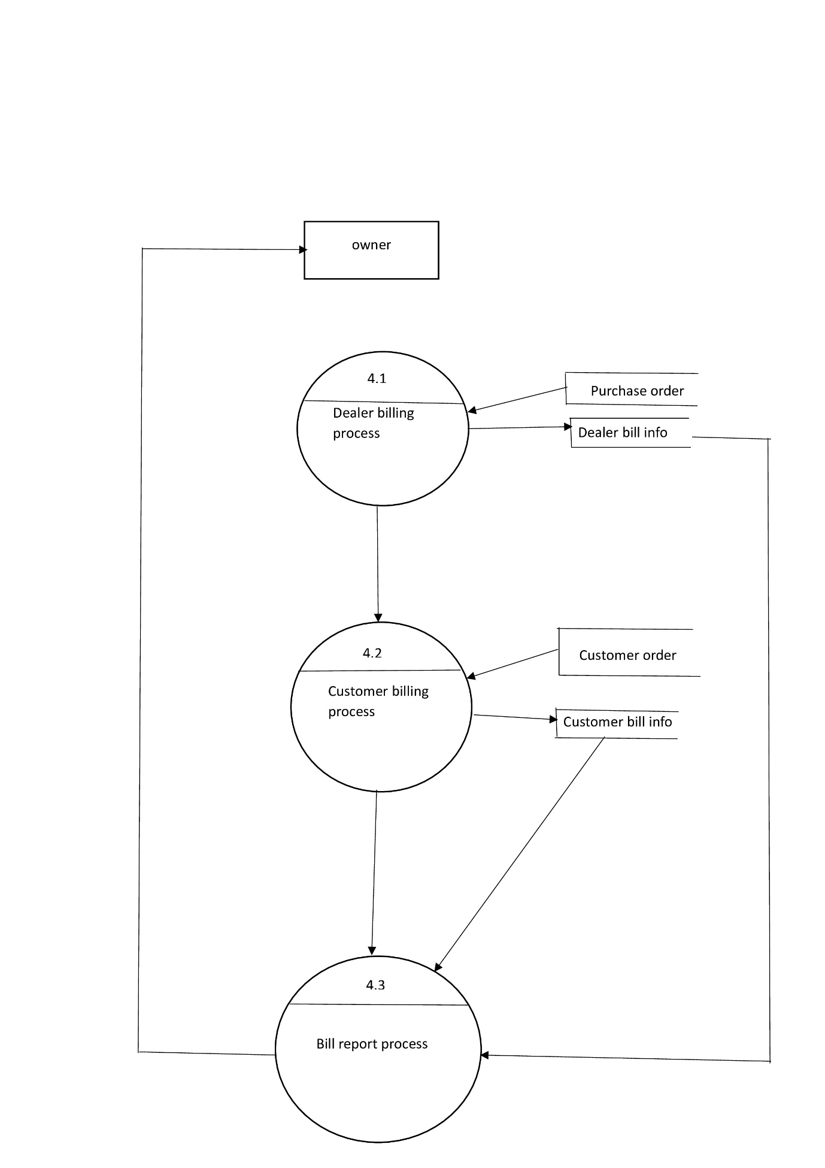

**ERD :**

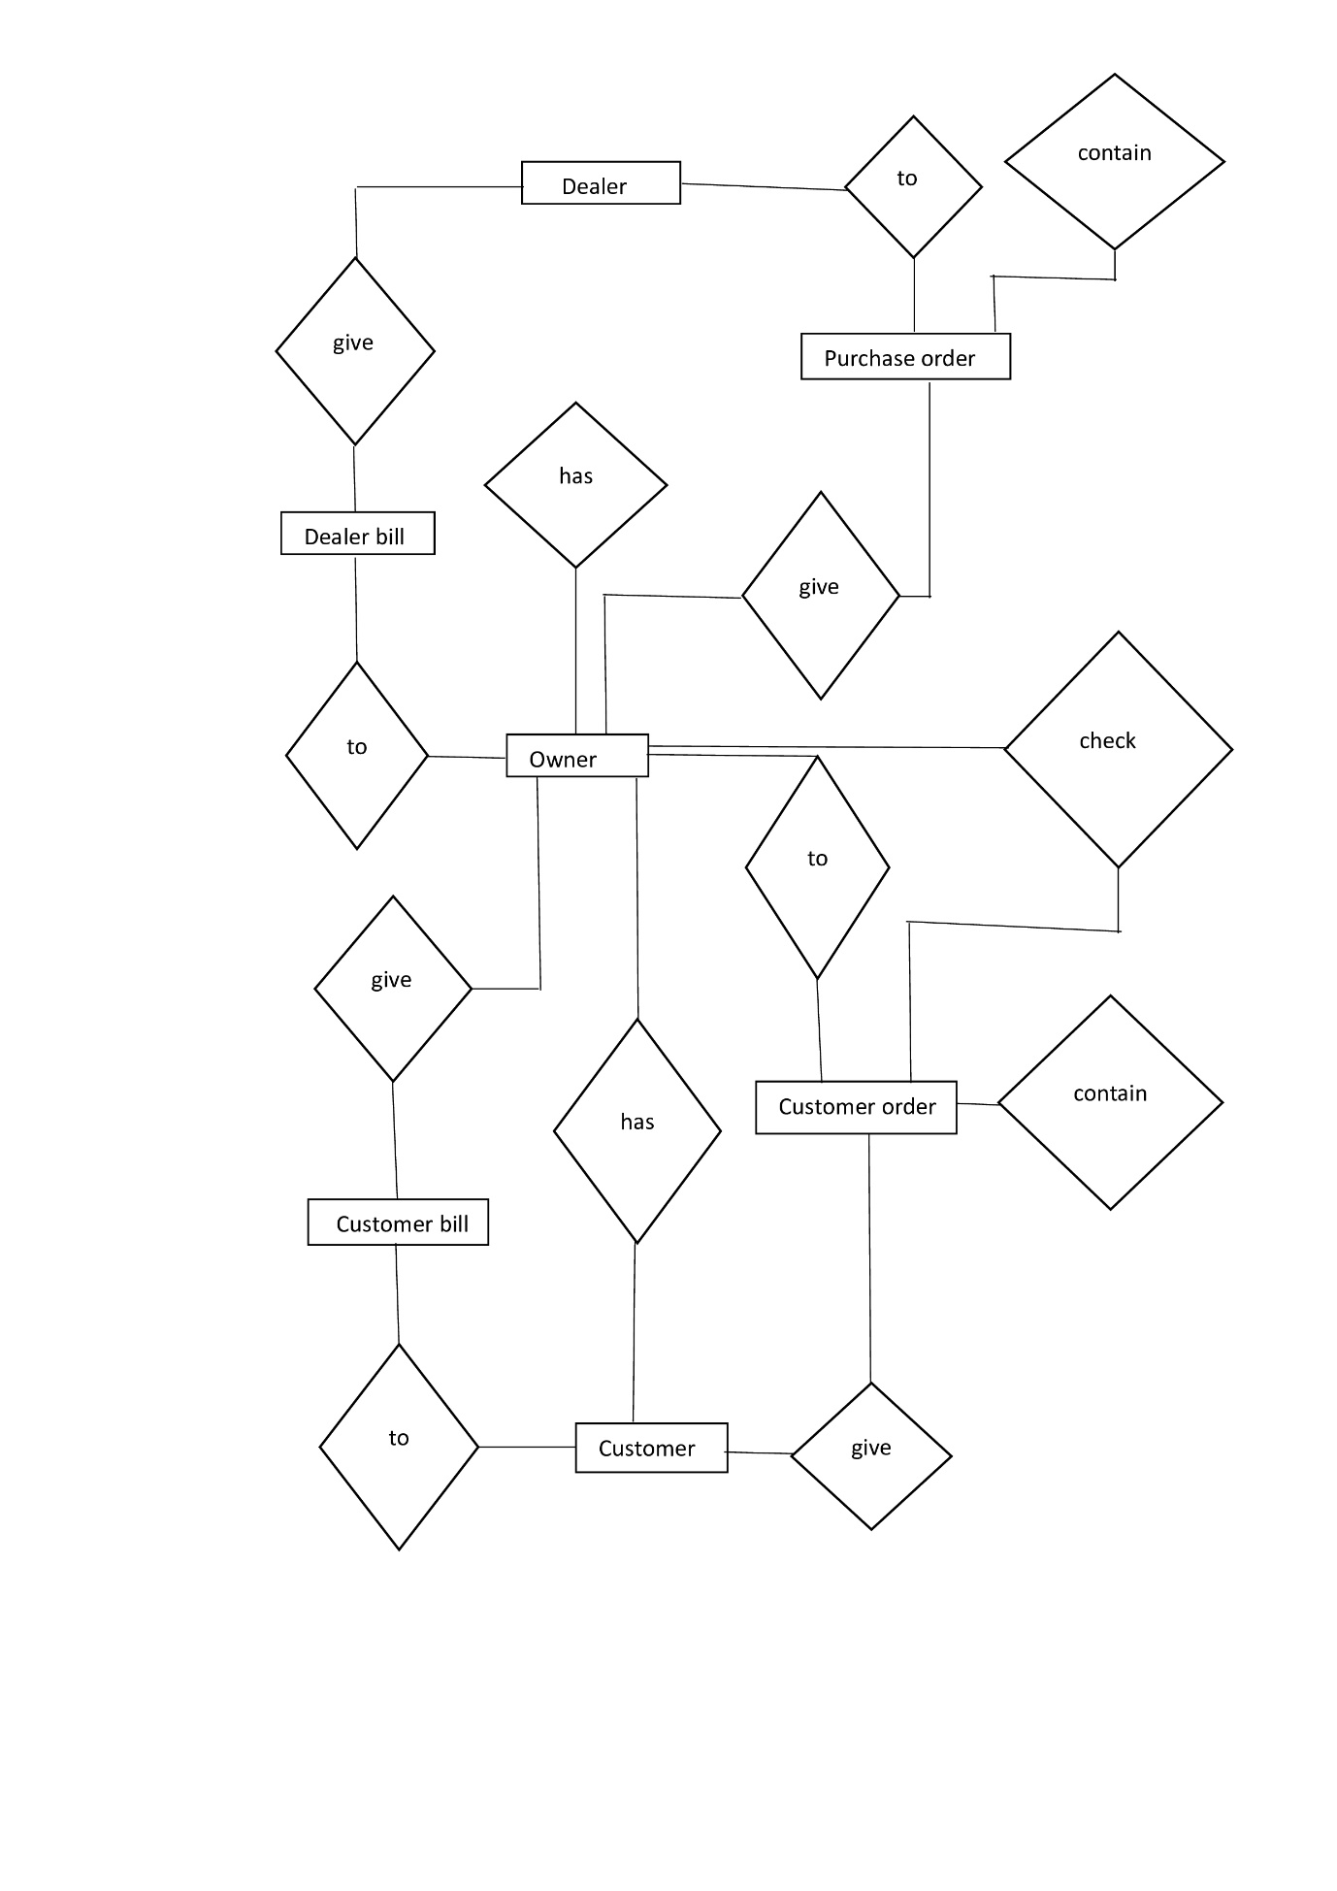

Chapter 4

**TOOLS USED**

4.1 SOFTWARE AND HARDWARE REQUIREMENTS……………………

4.2 FRONT END (C#.NET)…………………………………………………………

4.3 CONTROLS OF C#.NET…………………………………………………………

4.4 BACK END (SQL SERVER 2014)……………………………………………

4.5 CRYSTAL REPORT………………………………………………………………

### 4.1 SOFTWARE & HARDWARE REQUIREMENTS

### 

To run this software, you must have certain hardware & software installed on your computer. The minimum system requirements include:

* Software Requirements:
* Microsoft windows XP or later – Operating System
* C# .NET(Visual Studio 2015) – Front End
* Microsoft SQL server 2014 – Back end
* Crystal Reports (Built in C#.NET) version 9.0
* Hardware Requirements:
* Pentium Core2 Duo or higher processor
* LCD or higher resolution screen supported by

Microsoft windows.

* 1 GB of RAM or higher.
* A mouse as pointing device & keyboard to input data.
* Minimum 3 GB hard disk is required.
* A Laser printer for taking the printouts.

4.2 FRONTEND C#.NET

4.2.1 History of C#.NET:

During the development of the .NET Framework, the class libraries were originally written using a managed code compiler system called Simple Managed C (SMC). In January 1999, Anders Hejlsberg formed a team to build a new language at the time called Cool, which stood for "Cpp-like Object Oriented Language". Microsoft had considered keeping the name "Cool" as the final name of the language, but chose not to do so for trademark reasons. By the time the .NET project was publicly announced at the July 2000 Professional Developers Conference, the language had been renamed C#, and the class libraries and ASP.NET runtime had been ported to C#.  
  
C#'s principal designer and lead architect at Microsoft is Anders Hejlsberg, who was previously involved with the design of Turbo Pascal, Embarcadero Delphi (formerly CodeGear Delphi and Borland Delphi), and Visual J++. In interviews and technical papers he has stated that flaws in most major programming languages (e.g. C++, Java, Delphi, and Smalltalk) drove the fundamentals of the Common Language Runtime (CLR), which, in turn, drove the design of the C# language itself.  
  
James Gosling, who created the Java programming language in 1994, and Bill Joy, a co-founder of Sun Microsystems, the originator of Java, called C# an "imitation" of Java; Gosling further claimed that "[C# is] sort of Java with reliability, productivity and security deleted." Klaus Kreft and Angelika Langer (authors of a C++ streams book) stated in a blog post that "Java and C# are almost identical programming languages. Boring repetition that lacks innovation," "Hardly anybody will claim that Java or C# are revolutionary programming languages that changed the way we write programs," and "C# borrowed a lot from Java - and vice versa. Now that C# supports boxing and unboxing, we'll have a very similar feature in Java." Anders Hejlsberg has argued that C# is "not a Java clone" and is "much closer to C++" in its design.  
  
C# used to have a mascot called Andy (named after Anders Hejlsberg). It was retired on 29 Jan 2004.

4.2.2 What’s New in C#.Net?

* We can create applications such as windows applications, web applications, console applications and mobile applications which has user interface.
* The former lets you create mobile based web application were as the later lets you right application for pocket PC or other windows CE-based devices which run on a stripped-down version of framework (compact framework). This framework is designed to let you make application similar to those you run on desktops.
* .NET provides code-based security. .NET lets you decide the way you want your application to be used.
* One of the biggest changes in C#.NET is that now everything is object oriented. All items, even variables, are objects. All aspects OOP have been implemented in C#.NET except multiple inheritance, but it does supports interface.
* You can also create multi-threaded application in C#.NET. A threaded application can do a number of different things at the same time, running different execution threads.
* One of the biggest hurdles that C# programmers will have to overcome is the great change in visual basic syntax. C#.NeT itself will usually guide you while typing the syntax, tell you what you’re doing wrong & often will explain how to make it right.
* Web development is now an integral part of C#.NET

There are two major parts of web application: web forms, web servers. You can bind the controls on a web form simply by dragging those sources onto web forms & setting a few properties & calling few methods. For creating web servers’ controls there are two ways:

1. You can create user control-that are web form pages that are then embedded in other web forms pages
2. You can create custom server controls using a s/w development kit (SDK) provided with the .NET framework.

* ADO.NET is a new data –handling model that makes it easy to handle data on the internet. There are many new tools & a wizards for handling data in C#.Net, including tools to generate datasets from data connection wizard or the server explorer to drag & drop whole tables from data sources, as well as creating data adapters, connection objects & more.
* It supports structured exception handling, using an enhanced version of the Try…Catch…Finally syntax supported by other languages (such as c++ & java).

4.2.3 Visual studio .NET IDE:

An IDE (Integrated development Environment) intend to be a single work environment. It is more than an integrated editor, compiler & debugger. It is a common shell that hosts the entire assortment of tools. The Visual Basic 2005 IDE is a robust working. Components of IDE is shown in above figure that are;

1. Toolbox:

It is a most commonly used tool window. It provides a listing of various user interface components & other elements, which are provided to you to add into your project. You can add any item from toolbox to your project by selecting & dragging it on the form or by double clicking it.

1. Command / Immediate window:

Immediate window has been part of C# and command window has been part of Visual foxpro. Both the tools are available with .NET IDE.

Command window provides us capability to interact with IDE with some commands as like DOS command interpreter, it provides us prompt to which we can enter command to interact with IDE

Immediate window provides the capability to evaluate code statements directly and see results of this statement directly without creating the entire sample project.

1. Dynamic help:

This tool window provides context-based documentation. Instead of searching for particular help this window provides you direct help about the current selected item.

1. Server explorer:

This tool provides a visual linking to main resources: Database, Servers. This window provides you a listing of various database servers to which your application is connected as well as it also provides a list of servers of which you are using services

1. Properties window:

Properties window provides us a list of properties of current selected object. It also provides us facility to set us edit properties.

1. Solution explorer:

The solution explorer window enables you to view the objects or items that are included in your solution & grouped under layers such as projects, forms.

1. Class view:

Class view window displays all the classes that are used in our application. By double clicking on any classes listed in class view we can directly go to its definition.

1. Object browser:

The object browser is designed to assist you in working with the entire object as C#.NET is object oriented. Object browser provides you a list of objects with its methods, properties including all .NET classes. It is a quick reference to the classes available with framework & the classes that are developed by programmer.

4.3.4 What is .NET Framework?

In .NET main things are changed, one of the changes is the development of new foundation to all .NET development tools. This foundation is known as .NET Framework. .NET Framework provides two things-the basic runtime environment & set of foundation classes.

It is layered architecture components of framework. Architecture includes following components:

1] .NET Compatible Languages:

VB.NET, C#.NET, Jscript.NET, J#.NET etc. are languages compatible to .NET Framework. Application templates which are included in layer 3 can be developed using these languages.

2] Common Language Specification:

These are set of rules defined for all .NET compatible languages. If a component uses only CLS features then the component is guarantee to be accessible from any language that support CLS.

3] Common Type System:

CTS define how types are declared, used & managed in the runtime. It is also an important part of the runtime’s support for cross language integration .It is also called as superset of CLS.

4] Framework Class Library:

.NET supports some predefined classes; these are put under hierarchy called as namespace. This is same as MFC. Whenever you start any .NET application template 3 namespaces will be available by default are system, system. Data, system.XML

5] Application Templates:

The application templates are as follows:

1. Console Based:

This is an application type where user interact

with console for submitting I/P & reacting O/P.

1. Windows Form Application:

These are normal windows application uses

the form control as an interface.

1. .NET Remoting:

This is the new technology added to.NET to

design distributed application

1. Web form:

This is web tool available to design web

application.

1. XMLServices:

This is another new technology available in

.NET .These is used for writing web services.

1. ADO.NET:

It is completely disconnected architecture of

client application with database.

6] Common Language Runtime:

It is heart of .NET framework. It actually takes care of entire execution, memory management of .NET applications, irrespective of type of application. Following are some benefits of CLR:-

i. Performance improvement

ii. Cross integration

iii. Garbage collection

iv. Ability to compile once & run on any CPU

4.3 CONTROLS USED

Controls are graphical objects. Each control has their own attributes i.e. properties and methods. We can use these controls to use user inputs, display output, to import other applications and to trigger event procedures. These controls are described briefly below.

* Label

Labels are used to just label. Labels usually are used to display text that cannot be edited by the user. Probably the most common use of labels is to identify help information.

* TextBox

Every windows user is familiar with text boxes. They are exactly what their name implies: box-like controls in which you can enter text. Text boxes can be multiline, have scroll bars, be read-only, & have many other attributes.

* Button

Button are the plain control that you simply click & release. The button you see everywhere in visual basic application-usually just rounded rectangular, gray button with a option. Button provides a most popular way of creating & handling an event in your code.

* Date Time Picker

The DateTimePicker control enables you to provide a formatted date field that allows easy date selection. In addition, users can select a date from a dropdown calendar interface.

* ComboBox

Combo Box control is used to display data in a drop-down Combo Box. The Combo Box is made up of two parts-the top part is a text box that allows the user to type in all or part of a list item. The other part is a list box that displays a list of items from which the user can select one or more. you can allow the user to select an item from the list, or enter their data.

* MenuStrip

Menus are those controls that allow the user to make the selection & also hide away those selections when there not needed. you can add submenus to menus that will pop up when the user clicks an arrow in a menu item, display check marks, create menu separators, assign shortcut keys to menu item, even draw the appearance of menu items yourself.

**4.4 FEATURES OF SQ****L 2014**

*Below are the top 10 new features in SQL Server 2014.*

1. **In-MemoryOLTPEngine**  
   As mentioned above, SQL Server 2014 enables memory optimization of selected tables and stored procedures. The In-Memory OLTP engine is designed for high concurrency and uses a new optimistic concurrency control mechanism to eliminate locking delays. Microsoft states that customers can expect performance to be up to 20 times better than with SQL Server 2012 when using this new feature.
2. **AlwaysOn Enhancements**  
   Microsoft has enhanced AlwaysOn integration by expanding the maximum number of secondary replicas from four to eight. Readable secondary replicas are now also available for read workloads, even when the primary replica is unavailable. In addition, SQL Server 2014 provides the new Add Azure Replica Wizard, which helps you create asynchronous secondary replicas in Windows Azure.
3. **Buffer Pool Extension**  
   SQL Server 2014 provides a new solid state disk (SSD) integration capability that lets you use SSDs to expand the SQL Server 2014 Buffer Pool as nonvolatile RAM (NvRAM). With the new Buffer Pool Extensions feature, you can use SSD drives to expand the buffer pool in systems that have maxed out their memory. Buffer Pool Extensions can provide performance gains for read-heavy OLTP workloads.
4. **Updateable Columnstore Indexes**  
   When Microsoft introduced the columnstore index in SQL Server 2012, it provided improved performance for data warehousing queries. For some queries, the columnstore indexes provided a tenfold performance improvement. However, to utilize the columnstore index, the underlying table had to be read-only. SQL Server 2014 eliminates this restriction with the new updateable Columnstore Index. The SQL Server 2014 Columnstore Index must use all the columns in the table and can’t be combined with other indexes.

1.Objectives

* Launch Access and identify the parts of the screen
* Define fields and field properties constructing table structure.
* Enter and edit records in table.
* Find , sort data.
* Design custom queries to display data.
* Import and export data between excel and access.

2.Definations

**Relational Database:-** In relational database such as Access, data is stroed in tables made up of one or more fields(Access calls a column a field).

The data stroed in each one column must be od a single data type such as charcter, number or date. A collection of values from each column of a table is called a record or a row in the table.

Different tables can have the same column in common. This feature is used to explicitly specify a relationship between two tables. Values appearing in column A in one table are sheared with another table.

**Table :-**Tables are the main units of data storage in a database. A table is a collection of a data about a specific topic, it is made up of one or more fields.

**Field :-**A field is a column in a table and defines a data type for a set of values in a table. For example, a mailing list table might include fields for first name, last name, address, city, state, pin code and mobile number.

**Record :-** A record in a row in a table and is a set of values defined by fields. In a mailing list table each record would contain the data for one person as specified by the intersecting fields.

**Data Type :-** Data types are the properties of each field. A field only has one data type, such as character, number or date.

**Primary Key :-** A primary key is a value that can be used to identify a unique record in a table.

**Design view :-**It provides the tools for creating fields in a table.

**Datasheet view :-** It allows you to update, edit, and delete information from a table.

Database Components:-

An Access database consists of several different components. Each component listed is called a object.

**Tables**

Tables are where the actual data is defined and entered. Tables consist of records(rows) and fields(columns).

**Queries**

Queries are basically questions about the data in a database.

A query consists of specification inducting which fields, record, and summaries you want to see from a database. Queries allow you to extract data based on the criteria you define.

**Forms**

Forms are designed to ease the data entry process. For example, you Can create a data entry form that looks exactly like a paper form. People prefer to enter data into a well designed form, rather than a table.

**Reports**

When you want to print records from your database, design a report. Access even has a wizard to help produce mailing labels.

**Table Relationships**

To prevent the duplication of information in a database by repeating fields in more than one table, table relationship can be established to link fields of tables together.

4.4.1 INTRODUCTION TO ACCESS

What is structured query language, you ask? SQL is the set of instructions used to interact with databases. It allows users to create, retrieve, update, and delete data. Of course, this is a straightforward definition for such a complex subject. Let’s go a little deeper.

* SQL is a special-purpose programming language designed for managing data stored in a relational database management system.
* SQL is the language with which a coder communicates with a database to manipulate its data.
* It is their guiding hand, voice, and fingertips dragging across a screen, helping the coder navigate and organise the data as they see fit.
* It is how a coder converses with the machine.

SQL provides a standardised method for interacting with databases, making it possible for users to work with different database systems regardless of the vendor. Additionally, SQL is widely used in data analytics and business intelligence applications, as it enables users to extract meaningful insights from large datasets. Invented in the 1970s, SQL has since become one of the most widely used programming languages for managing and querying databases.

4.4 ABOUT CRYSTAL REPORT

A report is nothing but the desired output of any software or project. It is an effective way to present your data in a printed format and display the information in prescribed format, because you have control over the size and appearance of everything on report. You can display the sorted information in a report which is stored in database. You can prepare the reports as you need based on the queries and cannot be used to edit the data. You can use the reports to group data and show subtotals and grand totals.

Crystal report has many extensive capabilities and has been designed to provide you with the most possible flexibility in designing report. Crystal report is quick and easy to learn. It requires very little time before you will be designing interesting and informative reports for your needs.

VB.NET provides built in Crystal Report Application (ver 9.0). Hence there is no need to use any other software for Crystal Report. The crystal Report control allows user of visual basic.NET to access the report writing capabilities of crystal Report quickly and easily. You can draw lines, boxes, include textbox and labels.

Chapter 5

**Database**

**Structure**

Table description

1 Table Defination : company

Column Defination : tblcompany

* Primary key : compid

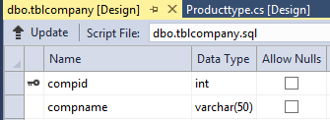

2 Table Defination : producttype

Column Defination : tblproducttyepe

* Primary key : protypeid

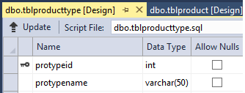

3 Table Defination : Flavour

Column Defination : tblproductflavour

* Primary key : flavourid

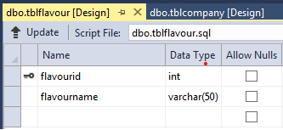

4 Table Defination : product

Column Defination : tblproduct

* Primary key : productid

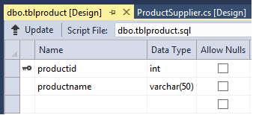

**5.Table Definition : supplier**

**Primary key : sup-id**

**Column Definition : tblsupplier**

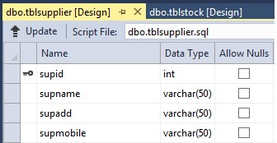

**6.Table Definition : price**

**Column Definition : tblprice**

**Foreign Key : productid ( Table – tblproduct)**

**Foreign Key : protypeid( Table- tblproducttype)**

**Foreign Key : compid (Table- tblcompany )**

**Foreign Key : flavourid( Table- tblflavour.)**

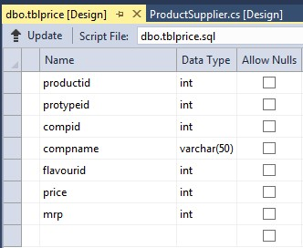

**7.Table Definition : Purchase Information**

**Primary Key : purid**

**Column Definition : tblpurchaseinfo**

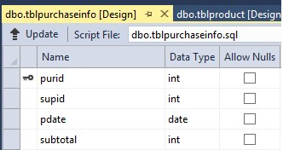

**8.Table Definition : Purchase Details**

**Foreign Key : purid ( Table – tblpurchaseinfo )**

**Foreign Key : protypeid( Table- tblproducttype)**

**Foreign Key : compid (Table- tblcompany )**

**Foreign Key : productid ( Table- tblproduct)**

**Foreign Key : flavourid( Table- tblflavour)**

**Column Definition : tblpurchasedetails**

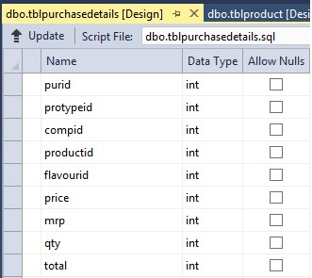

**7.Table Definition : Sale Information**

**Primary Key : saleid**

**Column Definition : tblsaleinfo**

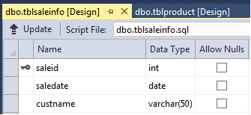

**8.Table Definition : Purchase Details**

**Foreign Key : saleid ( Table – tblsaleinfo )**

**Foreign Key : protypeid( Table- tblproducttype)**

**Foreign Key : compid (Table- tblcompany )**

**Foreign Key : productid ( Table- tblproduct)**

**Foreign Key : flavourid( Table- tblflavour)**

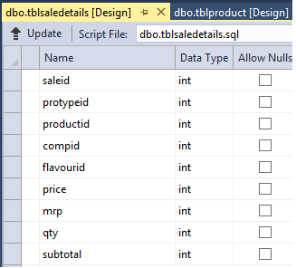

Chapter 6

**MDI Form**



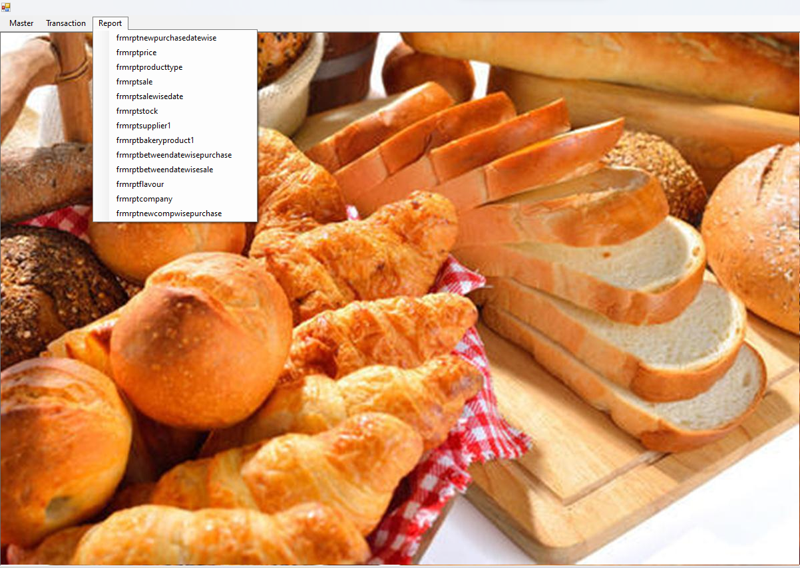

**Product company Product Company**

**Product Company**

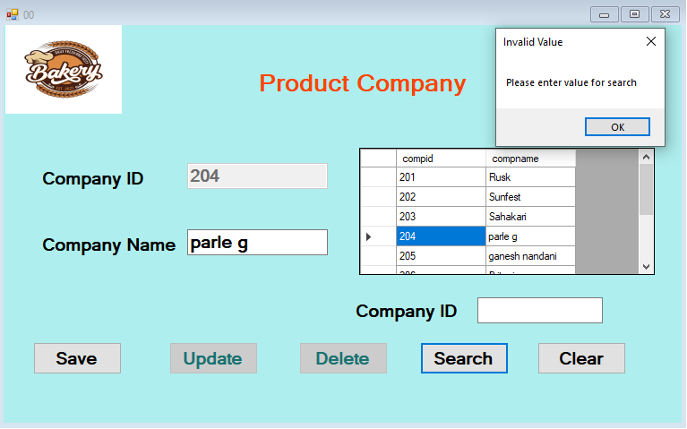

**Product Type**

pr

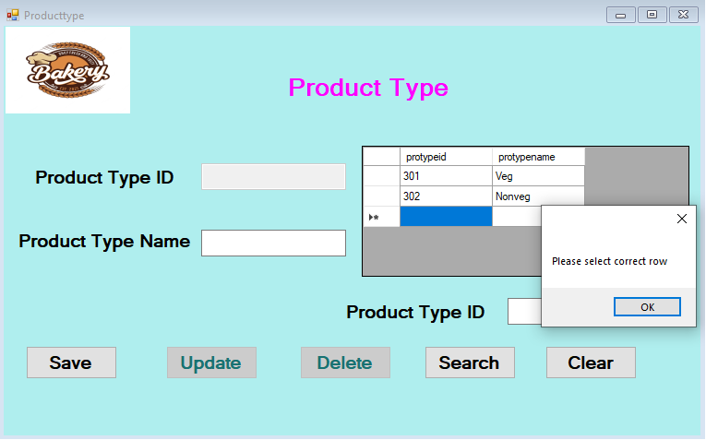

**Product Flavour**

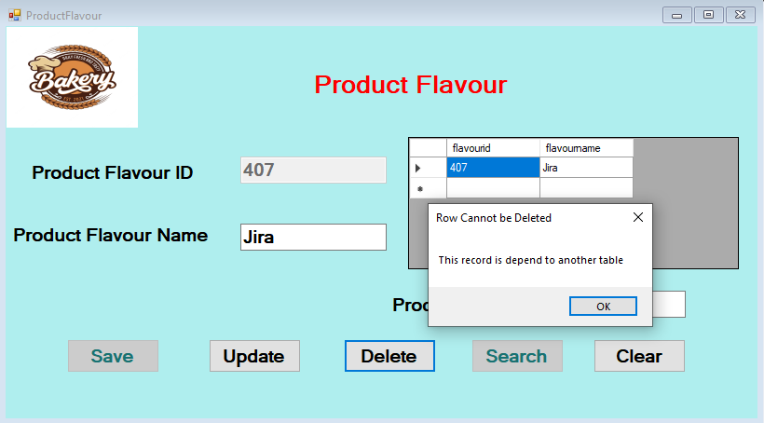

**Bakery Product**

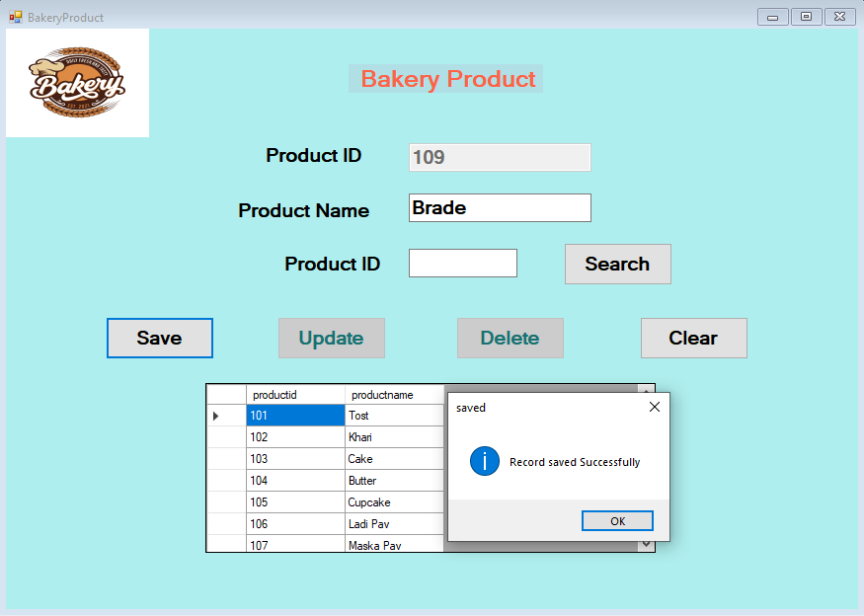

**Product Supplier**

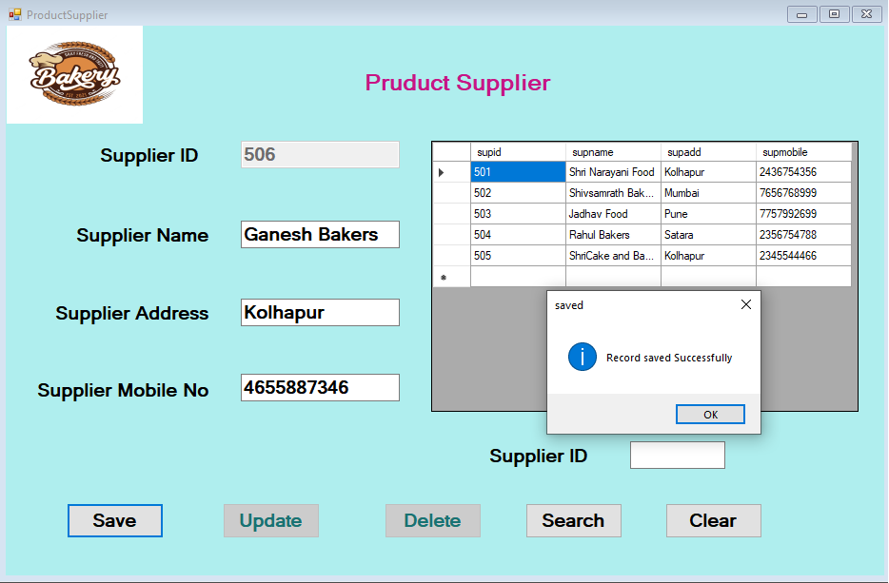

**Purchase Information Purchase Info**

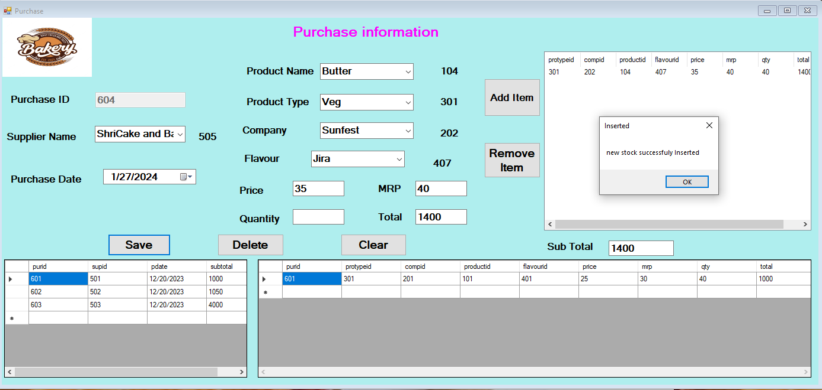

**Sale Information Product Company**

**Product Company**

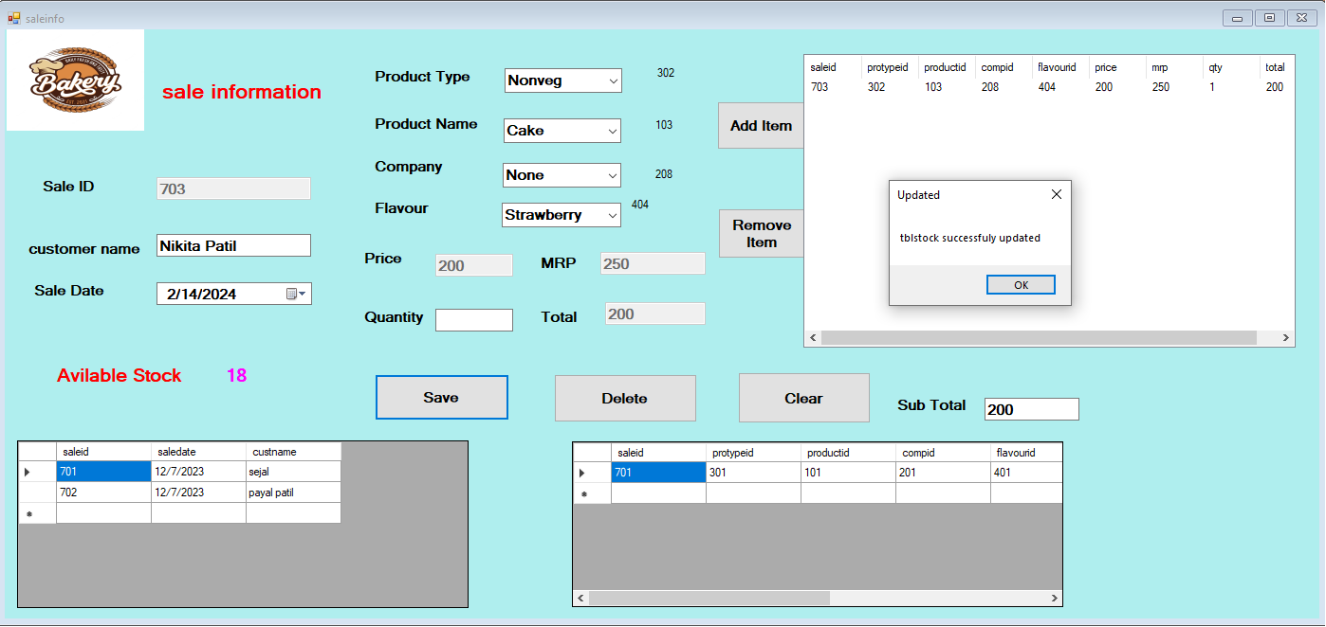

Report of Bakery product

reR

Report of Company

Report of Flavour

Report of Product Type

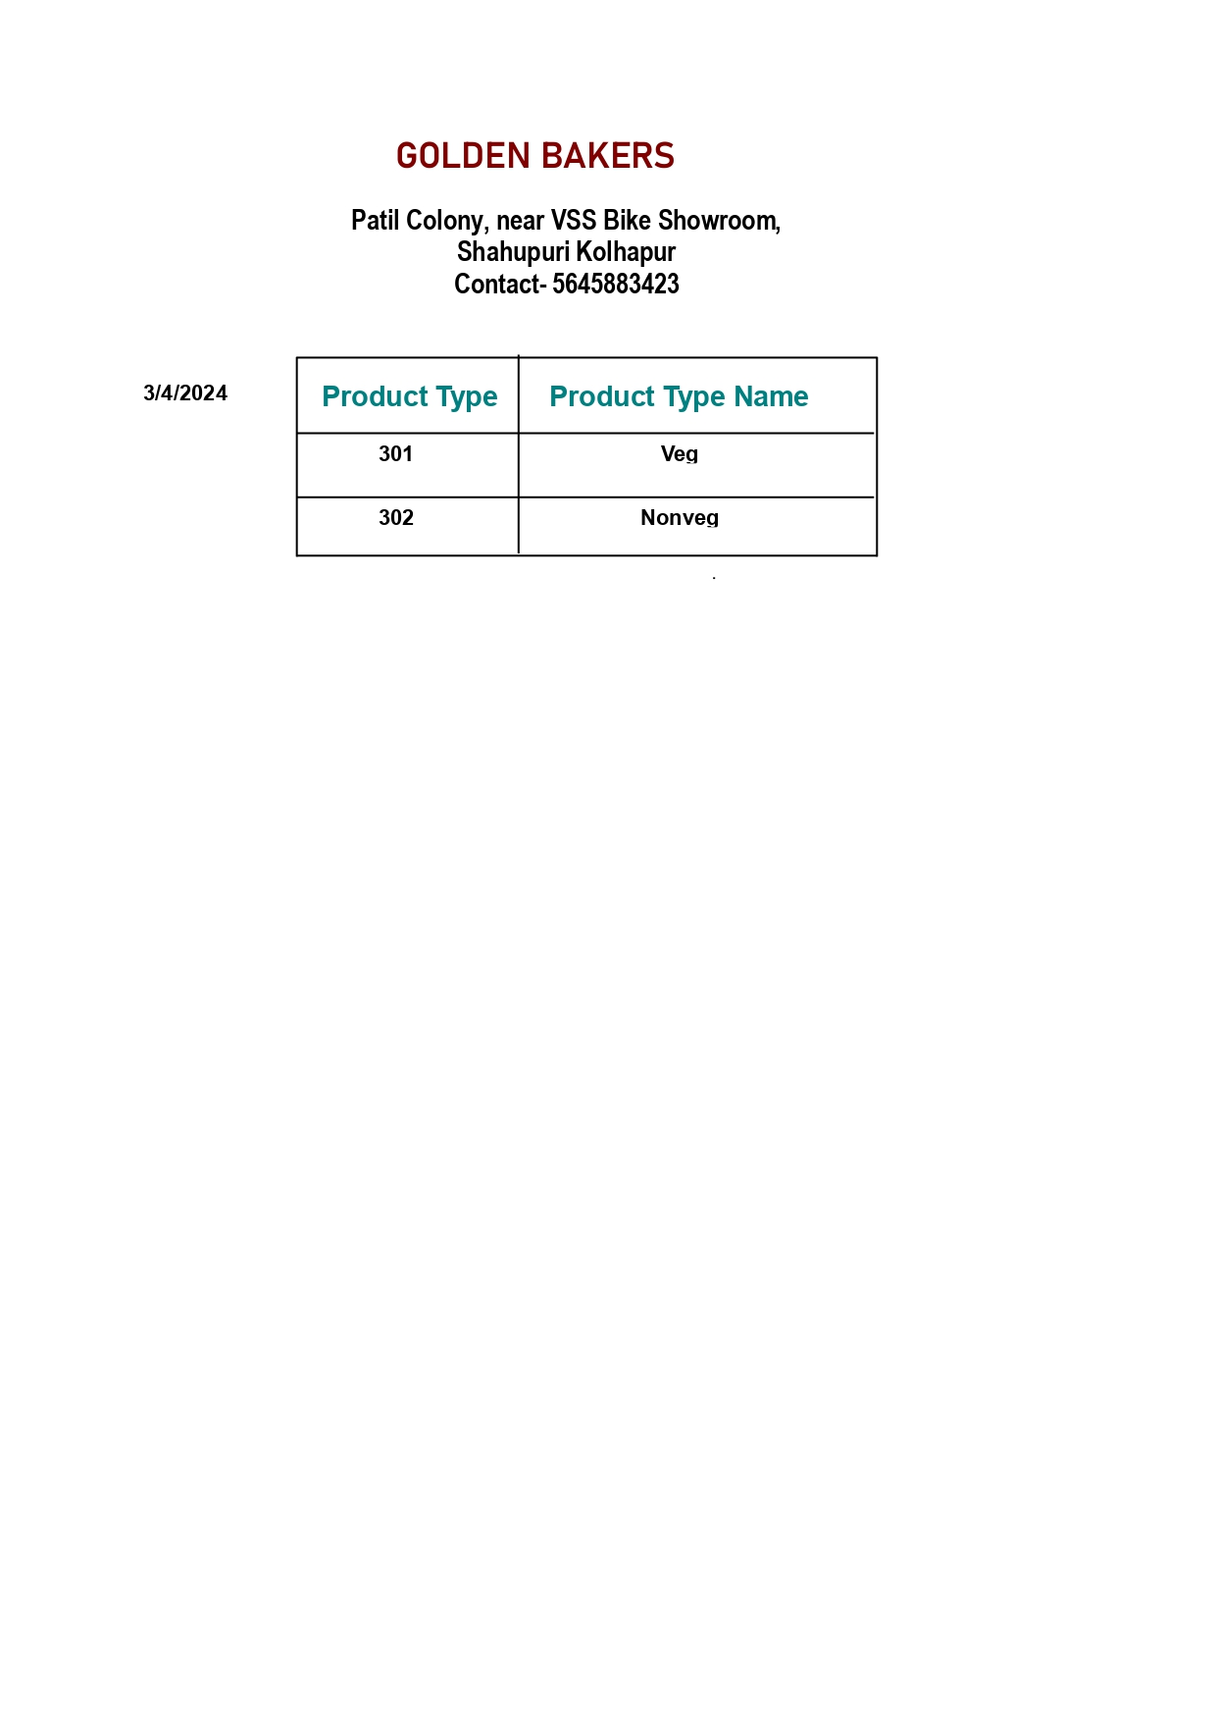

Report of Between Date Wise purchase

* + 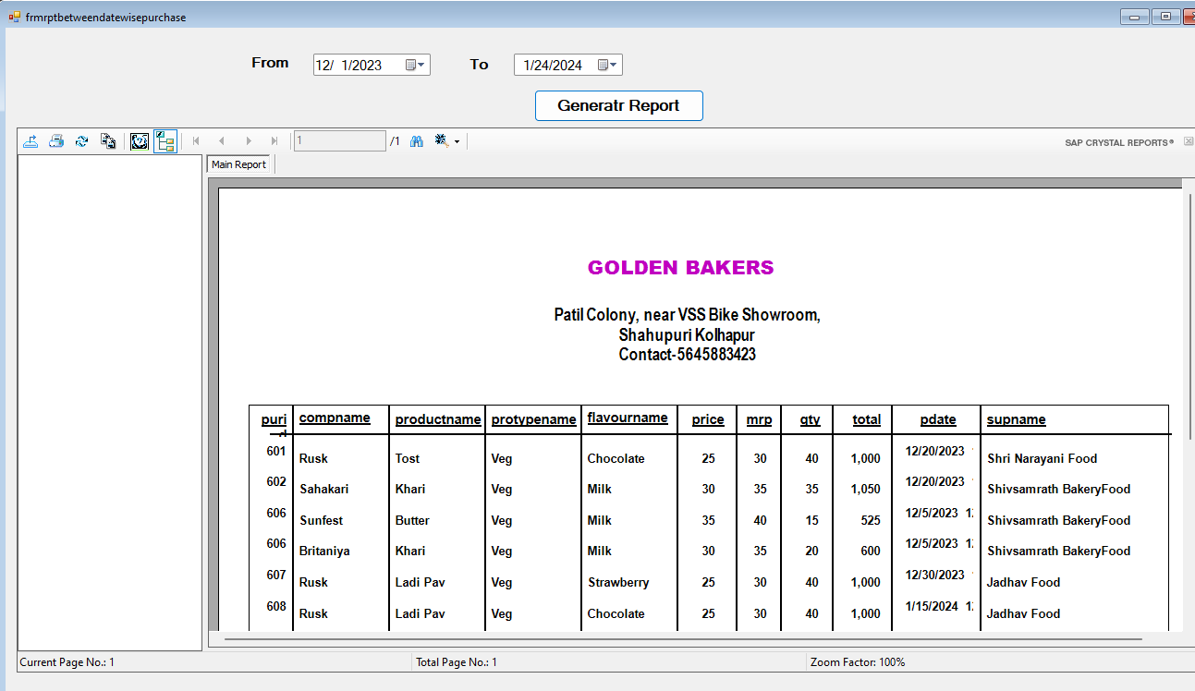

Report of Date Wise Pase

Report between Date Wise Sale

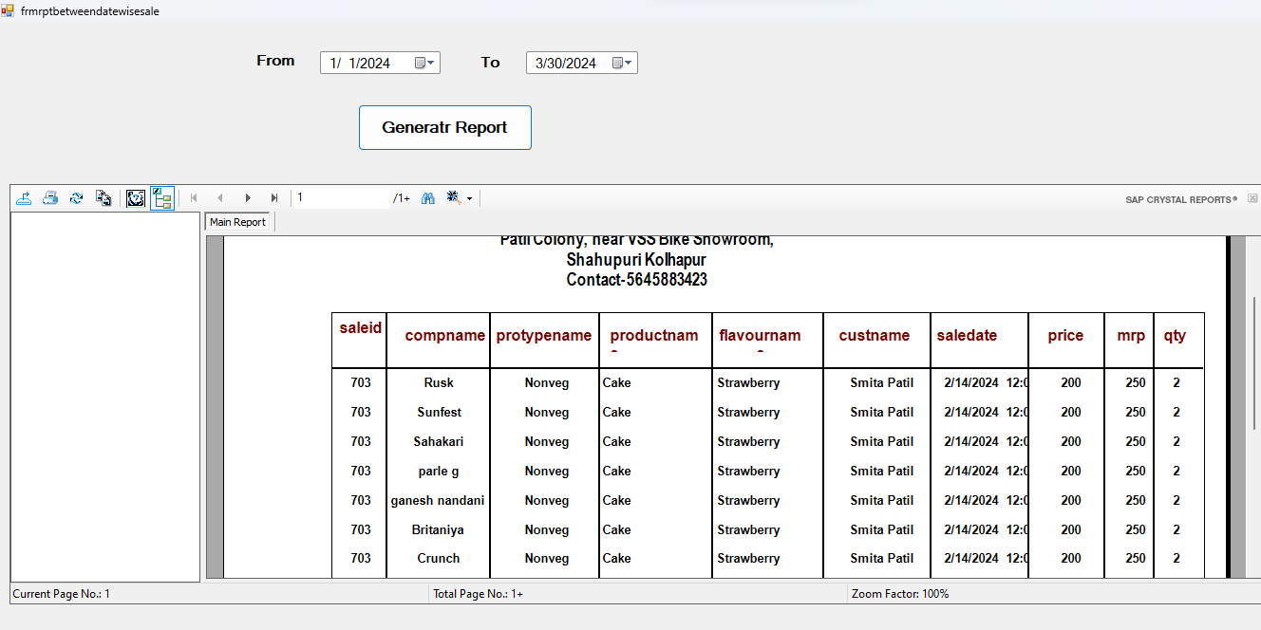

Report of Company Wise Price

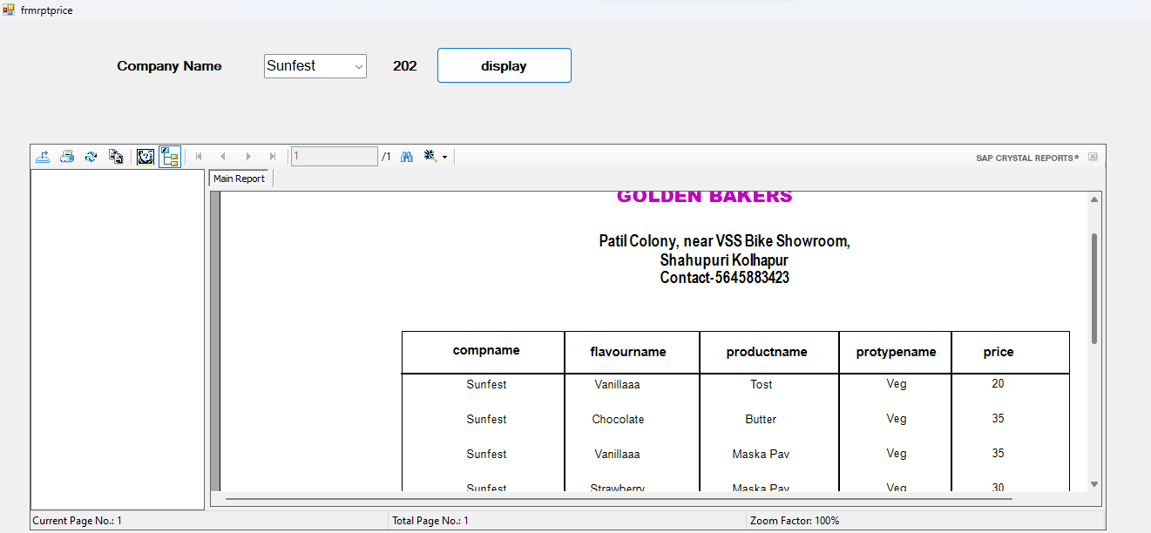

Report of Company Wise Sale

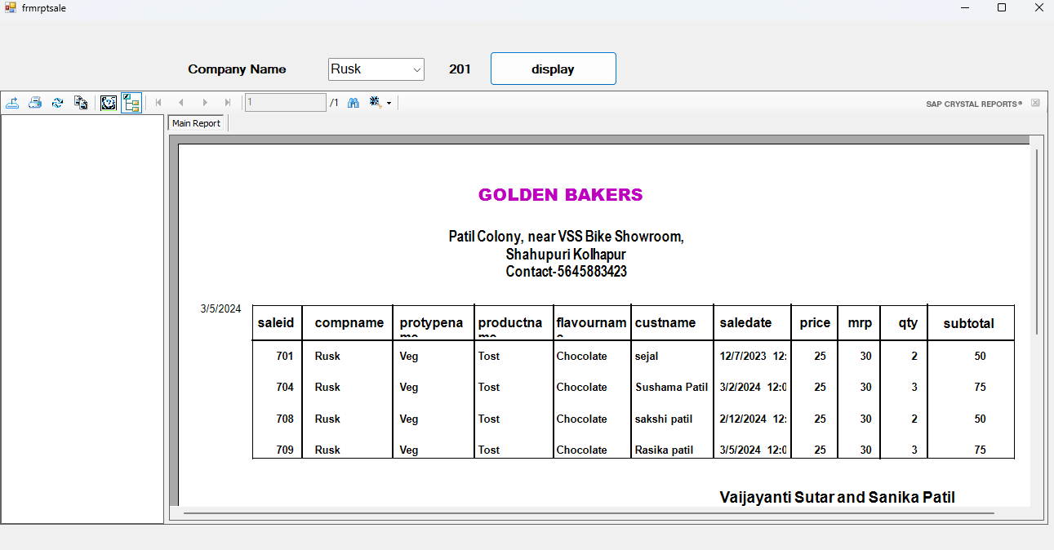

Report of Company Wise purchase

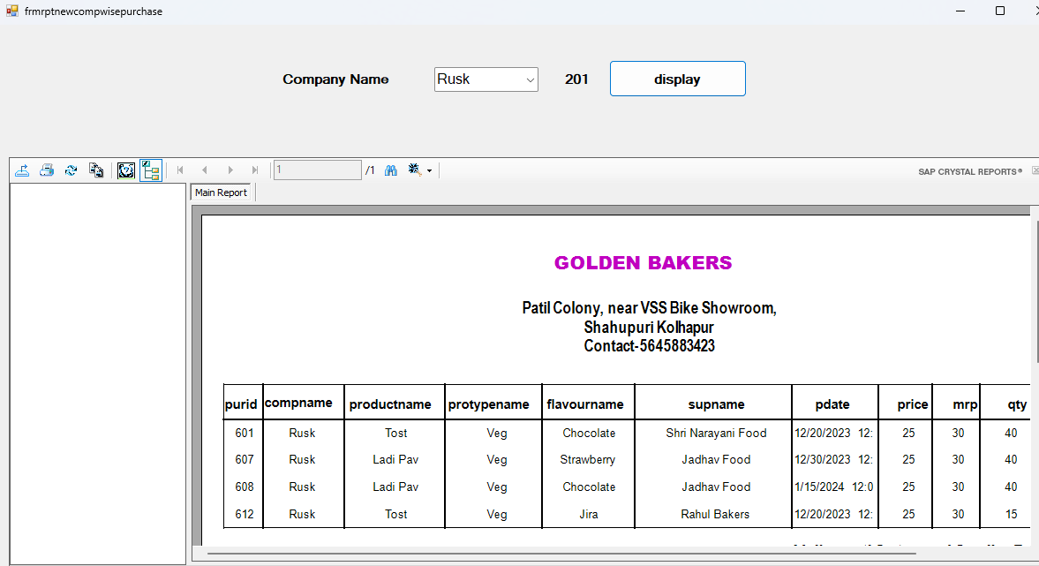

Report of Supplier Wise purchase

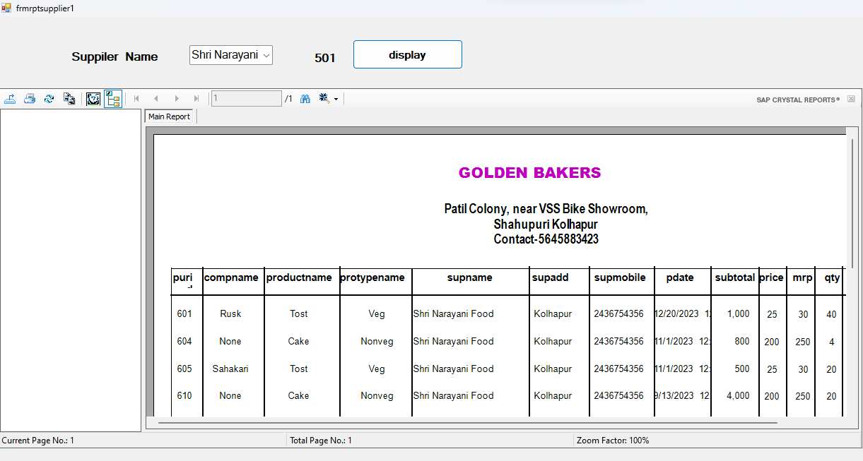

Report of Company Wise Stock

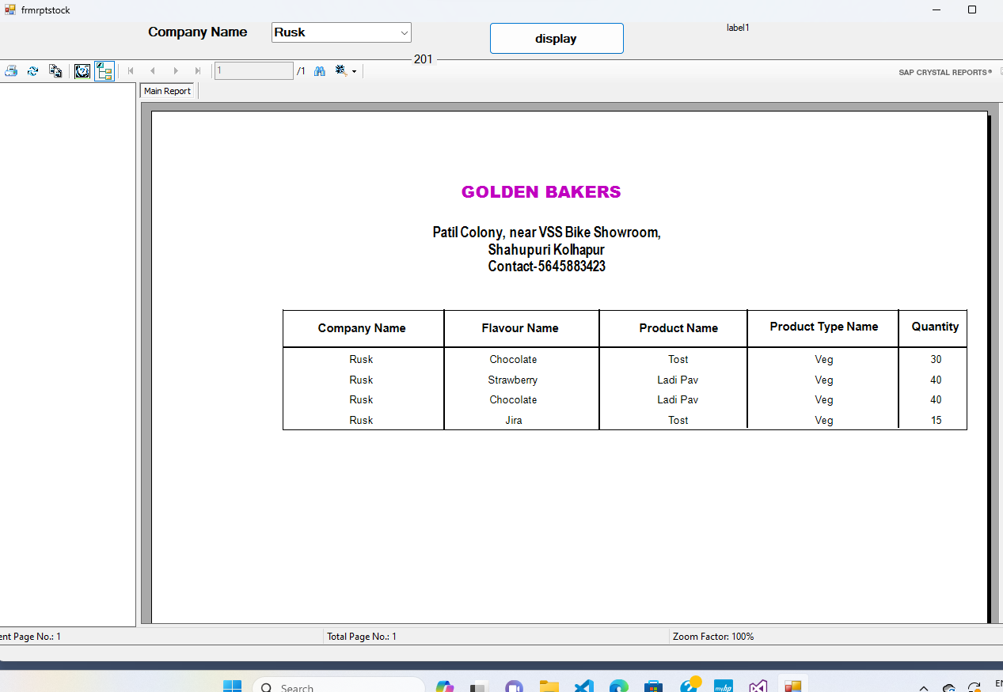

Report of Date Wise Sale

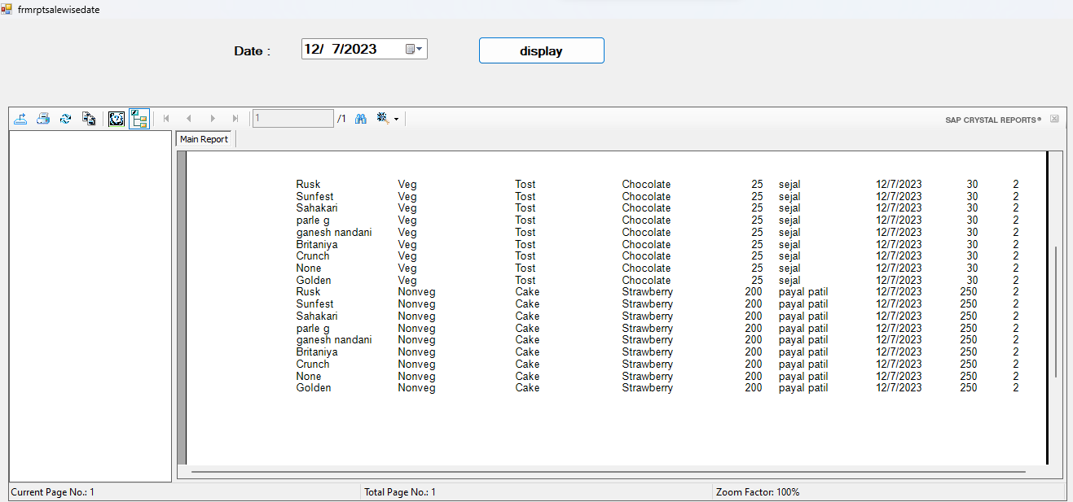

**CHAPTER 7**

**TESTING**

The four levels that the analyst uses for the quality assurance are:

1. TESTING
2. VERIFICATION
3. VALIDATION
4. CERTIFICATION

Quality assurance is review of the software product and relates documents for completeness, correctness, reliability and maintainability. It includes assurance that the system needs the specification and requirements for its indented use and performances.

System testing is expensive but critical process that can take as fifty percent of the budget for program development. The common view of testing held by user that it

is performed to prove that there are no errors in program. However, as indicated alone can not prove that software is free and clear of errors.

Therefore the most useful and practical approach is with the understanding that testing is a process of executing a program with the explicit intension of finding errors, that is program fails.

Testing is actually trying to make program failsafe. A successful test is one that fined an error. Analyst knows that an effective program does not guarantee the system reliability.

Reliability is the design issue. Therefore reliability must be designed into system.

Like testing, verification is also indented to find errors; executing program in simulated environment performs it.

Validation prefers the process using software in live environment in order to find errors. The feedback from validation phase generally produces changes in software to deal with errors and failures and may still need changes.

Software certification is an endorsement of the correctness of the program an issue that is rising in importance for information system application.

It is planned all above points will be considered for actual testing. It is hoped that using all above techniques can minimize failures. All the successes of the project depend upon the users, who are going to use the system. The higher-level staff is generally interested in the operational level staff. Taking into consideration all these things were out.

First all programmers were tested with dummy data at development center. Some bugs were and some procedures were required to be changed to help data entry-level personnel. All the changes were carried out again system was tested with real data records.

**CHAPTER 8**

**1.1 OBJECTIVE OF STUDY**

* To study the manual procedure of an Addmission Process .
* To provide user friendly software so that anyone can work comfortably satisfy his/her requirements.
* To present and submit the information to management more recently and more quickly.
* To provide the security, authority and future privacy of the confidential data.
* To reduce the manpower required to generate the reports.
* To provide software that is GUI (graphical user interface)
* Based application which is easy to operate and is of interactive nature so that even a worker having minimum knowledge of computing.
* Computer can operate it. Because GUI is highly interactive and is easy to understand and operate.
* To simplify the complicated method of maintaining registration data and Student information,token number,form number or fee amount and giving them reports.
* To identify the area of computerization.
* To keep database records for longer duration and make them available whenever needed.
* To make computerized services easy and fast.

**1.2 SCOPE OF THE SYSTEM**

1. This application software plays important role in Addmission because it maintains the various record of Addmissions.
2. It is not limited to any particular Addmission management.
3. It also maintains the details about the Students such as their registration information,result information, Fee information which pays them fee.

**1.3 CONCLUSION**

After designing and implementation of this

System we have come to the following conclusion.

* Due to computerization we can easily update, delete, or insert the data of eye clinic office and hence retrieval of any record that is stored becomes easier.
* Due to computerization, a lot of time is saved because all the paper work can be done on computer with greater accuracy.
* Changes can be made immediately and efficiently as we require.
* Print-outs of updated records can be taken.

**CHAPTER 9**

**BIBLIOGRAPHY**



* **Visual Basic. NET (Black Book)**
* **Steve Holzner**
* **Software Engineering**
* **Pankaj Jalote**
* **System Analysis and Design**
* **Award F. H.**
* [**www.google.com**](http://www.google.com)